December 31, 2018

From: Peter Houston
Houston Kendo Kyokai

Subject: Seminar by Susumu Takanabe Sensei

To: All Members of AUSKF

On behalf of Houston Kendo Kyokai and its members, we are pleased to serve as the Host Dojo for the Seminar by Susumu Takanabe Sensei on March 23-24, 2019. This event is open to all AUSKF members except for team USA, prospects and coaches for 18th World Kendo Championship. If you have any interest in trying out for team USA for the 18th WKC, please refrain from attending this event. This is a request by Takanabe Sensei.

Please complete all applicable materials and return them by Saturday, February 23th to the address below. Included in this package are following:

- Itinerary of Events
- Seminar Registration Form
- HKK Waiver of Liability
- NASA Waiver of Liability

LOCATIONS:

Saturday Seminar & Sunday Seminar @ Gilruth Fitness Center - 2101 E. NASA Pkwy, Houston TX 77058

Saturday Sayonara Dinner @ 888 Chinese Restaurant - 16744 El Camino Real, Houston TX 77062

ACCOMMODATIONS:

Courtyard by Marriott Houston NASA/Clear Lake
Book your group rate for Kendo Kyokai Fall Seminar (booking link)
Mention “Houston Kendo Kyokai” when making reservations by telephone.
18100 Saturn Ln
Houston, TX 77058
281-333-0220

Should you have any questions or comments, please do not hesitate to contact me. HKK is looking forward to seeing you all in Houston.

Sincerely,
Peter Houston
TEL: 512-968-6315
HoustonKendoKyokai@gmail.com

Schedule of Events

Saturday:

Seminar at the Gilruth Fitness Center

8:00 am: Facility Opens

8:00 am – 8:30 am: Registration

8:45 am: Morning Seminar Begins

11:30 am: Break for Lunch

1:00 pm: Afternoon Seminar Begins

3:00 pm: Seminar Ends

3:15 pm: Godo Keiko

4:00 pm: Event Ends

7:00 pm: Dinner at 888 Chinese Restaurant

Sunday:

Seminar at the Gilruth Fitness Center

8:00 am: Facility Opens

8:45 am: Morning Seminar Begins

10:30 am: Seminar Ends

10:45 am: Godo Keiko

11:30 am: Event Ends

Seminar Registration Form

Name:

Age:

Address:

City: State: Zip:

Phone: ( ) -

Email:

Dojo:

Rank:

Emergency Contact

Name (Relationship):

Phone Number:

Please mark the appropriate items and fill in the fee amount.

Seminar Registration ($40)* $

Late Registration (post mark after 02/16/2019) ($10) $

Lunch Beef Bento ($15)* # $

Lunch Chicken Bento ($15)* # $

Lunch Vegetarian Bento ($15)* # $

Sayonara Dinner - ($40)* # $

Donations $

TOTAL $

Please return the registration form along with the waiver of liability, and a check payable to “Houston Kendo Kyokai” by February 23, 2019. We ask that each Dojo/Club designate a “Dojo Representative” to consolidate and facilitate the registration for your own Dojo.

Dojo Representatives, please send only one envelope with your Dojo/Club Forms, waivers, and check for payment and mail it to:

Peter Houston

14110 Briarworth Dr. Houston TX 77077

Thank you.

Tenegui desgined and written by Susumu Takanabe Sensei

KOKKISHIN

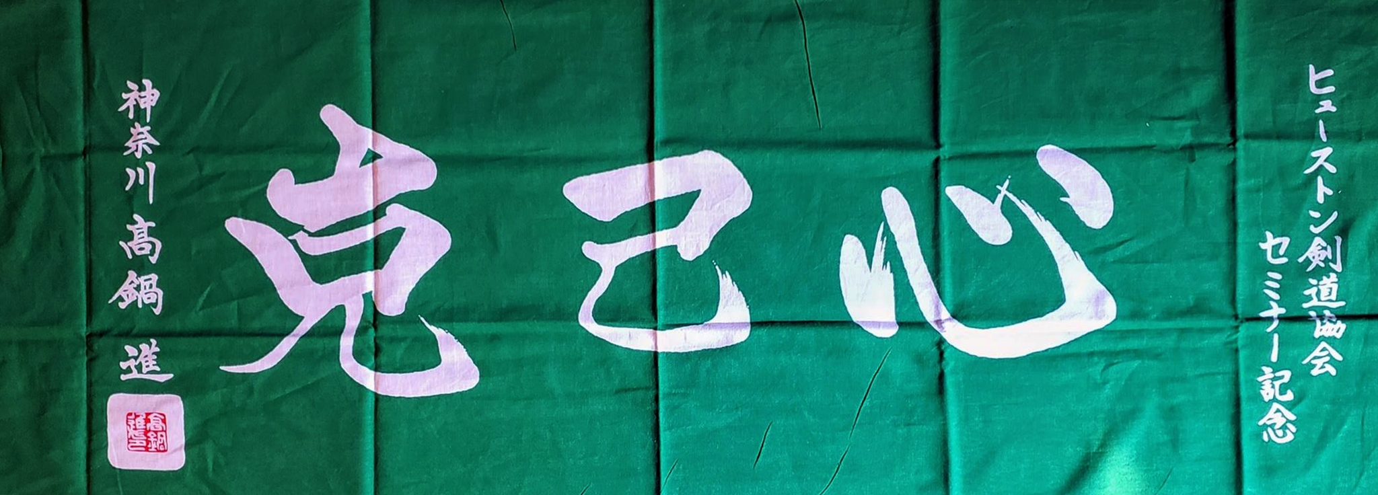

Above tenegui has been personally designed and written by Susumu Takanabe Sensei and is free to the first 150 people to register for the event.

Kanji meaning.

克 - Overcome
己 - Yourself
心 – Heart/Spirit
Thank you,
HKK

WAIVER OF LIABILITY
FOR PARTICIPATION OF EVENTS IN THE March 23-24, 2019

I, the below signed Participant, intending to be legally bound, do hereby, for myself, my heirs, assigns, executors and administrators, waive, release, and forever discharge any claims for damages, illness, injuries and/or death which may hereafter accrue to me against the All United States Kendo Federation, Houston Kendo Kyokai, Gilruth Fitness Center, NASA, 888 Chinese Restaurant , The City of Houston, The City of Seabrook and their members, employees, instructors, agents, invited sensei’s and participants in the March 22-25, 2019 Kendo event at Gilruth Fitness Center for any and all damages which may be sustained or suffered by me in connection with, in association with, travel to or from or participation in the Kendo Event. I further agree to indemnify and hold harmless the All United States Kendo Federation, Houston Kendo Kyokai, Gilruth Fitness Center, NASA, 888 Chinese Restaurant, The City of Houston, The City of Seabrook and their members, employees, instructors, agents, invited Sensei and Participants in the March 22-25, 2019 Kendo event for any claims I may have outlined herein.
Arbitration: All claims and disputes arising under or relating to this Agreement are to be settled by binding arbitration in the state of Texas or another location mutually agreeable to the parties. An award of arbitration may be confirmed in a court of competent jurisdiction.

Participant: (Print and Sign)

_______________________________________________________ Date: ________________

*Parent or Legal Guardian: (Print and Sign)

_______________________________________________________ Date: ________________

*(Note: Parent or Legal Guardian must sign is the Participant is under the age of eighteen years old)

Hold Harmless Agreement

User agrees to indemnify and hold harmless the United States, its agents, representatives, officers and instrumentalities (including the NASA Exchange-JSC) and employees thereof, from any and all claims, demands, actions, judgments, debts or cost arising from the injury to or death of any person(s), or for damage to or loss of any property as a result of activities under this agreement, whether such damage is the result of negligence or otherwise.

NASA Exchange-JSC will recover all costs for any damage or loss to the premise, facility or facility contents caused by or arising out of the client's activities while using the facility. Additionally, any loss or damage to other's property and/or injury or death to any person(s) caused by or arising out of the client's activities while using the facility will be the responsibility of the group using the facility.
User agrees U.S. Federal Law shall govern this agreement for all purposes, including, but not limited to, determining its validity, the meaning of its provisions, and the rights, obligations and remedies of the parties.

In the event of an emergency user must notify Starport Staff inside the building. If there is need of ambulance call 281.483.3333 from a phone.

Non-scuff shoes must be worn in the gym.

____________________________________________________________________________________Signature Printed Name Date

