Shin Sou Fu Kan Tulsa
ABOUT THE EVENT
It’s with great pleasure we would like, to announce the 2021 July Shin Sou Fu Kan seminar. We will be conducting a free training event featuring instructors from the Southwest to participate in an event to grow stronger together.
This is a free event, and open to beginners and experienced kendo practitioners a like. The first half of practice will be dedicated to beginners practice. Please RSVSP with Michael Lindsay Sensei at Michael@Tulsakendo.com
The event will also be broadcast online via zoom for anyone who cannot make it in person.
The use of masks are encouraged for this event.

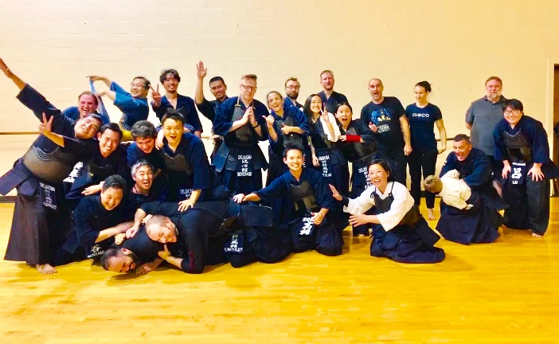
Visiting instructors
  - Joshua Kan 5dan (Houston Kendo Kyokai)
  - Aaya Sakaguchi 4dan (Arkansas Kendo )

TIME
JULY 31, Saturday
12:15pm-4:30pm

Dinner with Sakaguchi sensei and Kan Sensei
6PM at Roosevelt’s

ADDRESS
SEMINAR LOCATION:
Charles Schusterman Jewish Community Center
2021 E 71st St, Tulsa, OK 74136

DINNER LOCATION:
Roosevelt’s
1551 E 15th St, Tulsa, OK 74120

ONLINE MEETING LINK
ZOOM APP LINK
https://us02web.zoom.us/j/86144583890
Meeting ID: 861 4458 3890

WEB BROWSER LINK
https://zoom.us/wc/join/86144583890
- Link will be active 10 Minutes before each session
- Please mute yourself upon entering the practice
- PIN the main speaker during each session
HOW TO INSTALL ZOOM
Step 1 Click on the link:
https://us02web.zoom.us/j/86144583890

Step 2: Click on Download Now
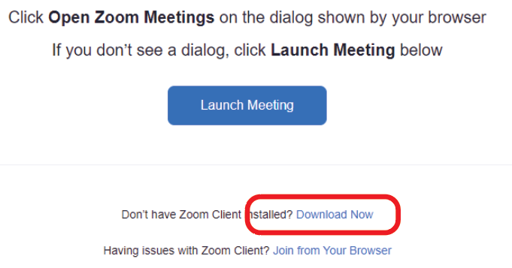

PIN THE SPEAKER
To pin the speakers video click on the … over their screen and select PIN option
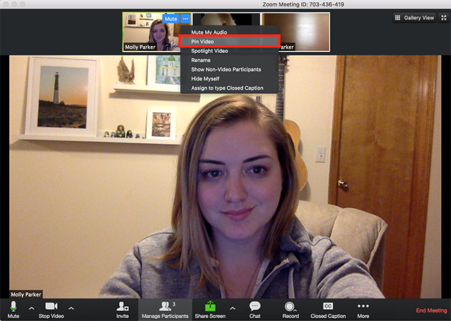

WAIVER OF LIABILITY
FOR PARTICIPATION OF EVENTS IN THE SHIN SOU FU KAN JULY SEMINAR 2021

I, the below signed Participant, intending to be legally bound, do hereby, for myself, my heirs, assigns, executors and administrators, waive, release, and forever discharge any claims for damages, illness, injuries and/or death which may hereafter accrue to me against the SWKIF, Tulsa Kendo Shin Sou Fu Kan Dojo, The City of Tulsa, their members, employees, instructors, agents, invited sensei, and participants in the SHIN SOU FU KAN JULY SEMINAR, for any and all damages which may be sustained or suffered by me in connection with, in association with, participation in the SHIN SOU FU KAN JULY SEMINAR. I further agree to indemnify and hold harmless the SWKIF, Shin Sou Fu Kan Dojo, the Shi Ku Kai Dojo, The City of Tulsa, their members, employees, instructors, agents, invited sensei, and participants in the SHIN SOU FU KAN JULY SEMINAR in Tulsa, OK for any claims I may have outlined here in.

Participant:

________________________________________________________________ Date: ________________
SIGNATURE PRINTED NAME

*Parent or Legal Guardian:

________________________________________________________________ Date: _______________
SIGNATURE PRINTED NAME
*(Note: Parent or Legal Guardian must sign is the Participant is under the age of eighteen years old)

Please E-mail an Image of the Signed waiver by 07.30.2021
To:
Michael@Tulsakendo.com

