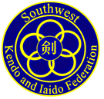

Omaha Kendo & Iaido Kyokai

August 1, 2018

To: All Members of the Southwest Kendo and Iaido Federation and AUSKF

2018 SWKIF Fall Seminar and Shinsa – Registration

On behalf of SWKIF & Omaha Kendo & Iaido Kyokai, we would like to invite you to the 2018 SWKIF Fall Seminar and Shinsa in Omaha, Nebraska, October 12-14, 2018.

Please complete all applicable materials and return them by Friday, Sep. 28, 2018 to the address below. Included in this package are the following:

- Itinerary of Events
- Seminar Registration Form
- T-Shirt Information
- Waiver of Liability
- Dojo Consolidated Seminar Registration Form (Separate Excel File)
- Shinsa Registration Material (Separate PDF File. Submit directly to SWKIF)

Locations:

Friday Godo Keiko @ Benson Community Center - 6008 Maple St, Omaha, NE 68104
Saturday Seminar & Sunday Shinsa @ Westside Community Conference Center - 3534 S 108th St, Omaha, NE 68144
Saturday Dinner @ Maru Korean Restaurant - 2314, 5032 S 108th St, Omaha, NE 68137

Accommodation:

We have reserved a block of rooms at the following hotel:
Courtyard by Marriott Omaha Aksarben Village
1625 S 67th St, Omaha, NE 68106
Here is the link to make reservations: Book your group rate for Omaha Kendo

Please do not hesitate to contact us if you have any questions. We look forward to seeing you all in Omaha

Sincerely,

Omaha Kendo & Iaido Kyokai
Omahakendokai@gmail.com

Itinerary of Events
SWKIF Fall 2018 Kendo Seminar and Shinsa

Fri. Oct. 12, 2018 Godo Keiko & SWKIF Board Meeting

6:00 pm – 8:30 pm Godo Keiko at Benson Community Center
6:00 pm – 9:00 pm SWKIF Board Meeting Courtyard by Marriott Omaha Aksarben Village

Sat. Oct. 13, 2018 Seminar and Dinner

8:00 am Westside Community Conference Center opens
8:00 am – 8:30 am Registration
8:45 am – 11:30 am Morning Seminar Session
11:30 am – 1:00 pm Lunch
1:00 pm – 3:30 pm Afternoon Seminar Session
3:30 pm – 4:30 pm Godo Keiko
4:30 pm – 5:00 pm Cleanup and Shinsa setup
6:30 pm – 9:30 pm Dinner at Maru Korean Restaurant

Sun. Oct. 14, 2018 Shinsa

7:45 am – 8:15 am Shinsa Registration
8:30 am – 11:30 am Testing
11:30 am - 12:30 pm Godo Keiko (Time Permitting)

SWKIF Fall 2018 Kendo Seminar Registration Form

Name: Age:

Address:

City: State: Zip:

Phone: ( ) -

Email:

Dojo: Rank:

Emergency Contact

Name (Relationship): Phone:

Please mark the appropriate items and fill in the fee amount.

Seminar Registration for SWKIF Members ($35) $

Seminar Registration for outside SWKIF ($45) $

Late Registration (post marked after 09/30/2018) ($10) $

Lunch ($14)* # $

Saturday Dinner - ($40)* # $

OKIK T-Shirt ($25) * # $

Donations $

TOTAL $

Saturday Lunch includes sandwich, chips and choice of dessert. Please indicate your choices.
Meat: Turkey _________ Roast Beef _________ Ham _________Veggie_________
Cheese: American ________ Swiss _________ Provolone _________
Dessert: Fruit ________ Cookie __________

OKIK T-shirt size: _________________
We ask that each Dojo/Club designate a “Dojo Representative” to consolidate and submit the registration for your own Dojo.

Dojo Representatives:
Please send only one envelope of Dojo/Club registration forms and the waivers, with one check payable to “Omaha Kendo & Iaido Kyokai” by September 28, 2018 to the following address:

Mi Ryang Moon
18406 W Dodge Hills Plz # 113, Elkhorn NE 68118

Order Omaha Kendo & Iaido Kyokai T-Shirt

Please support Omaha Kendo & Iaido Kyokai by purchasing this OKIK T-shirt.
This limited edition single run T-shirts are $25 each.
Please indicate the size on your registration form so we can have them ready for you at the seminar.

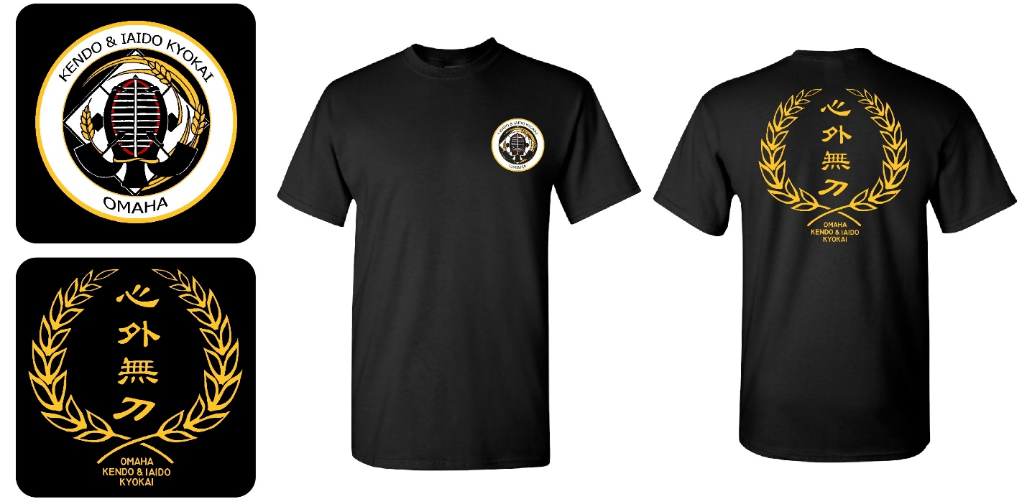

The back image is a phrase from the writings of the swordsman, Yamaoka Tesshu, and relates the concept that a powerful, resolved spirit/mind is a key element for the practitioner.

Thank you very much for supporting OKIK!

WAIVER OF LIABILITY
FOR PARTICIPATION OF EVENTS
Omaha Kendo & Iaido Kyokai
SWKIF Fall 2018 Kendo Seminar

I, _____________________, the below signed Participant, intending to be legally bound, do hereby, for myself, my heirs, assigns, executors and administrators, waive, release, and forever discharge any claims for damages, illness, injuries and/or death which may hereafter accrue to me against the Omaha Kendo & Iaido Kyokai, Southwest Kendo & Iaido Federation, City of Omaha Parks and Recreations, Westside Community Schools, Maru Korean Restaurant, and the participants in the SWKIF Fall 2018 Kendo Seminar, for any and all damages which may be sustained or suffered by me in connection with, in association with, travel to or from or participation in the SWKIF Fall 2018 Kendo Seminar. I further agree to indemnify and hold harmless the Omaha Kendo & Iaido Club, Southwest Kendo & Iaido Federation, City of Omaha Parks and Recreations, Westside Community Schools, Maru Korean Restaurant, and the participants in the SWKIF Fall 2018 Kendo Seminar, for any claims I may have outlined herein.

Participant Signature:

___________________________________________________ Date: ____________________

AUSKF Membership Number If Applicable: _________________________

*Parent or Legal Guardian Signature:

___________________________________________________ Date: ____________________

*Note: Parent or Legal Guardian must sign if the Participant is under the age of eighteen years old.

