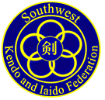
August 08, 2017

From: Peter Houston
Houston Kendo Kyokai

Subject: 2017 SWKIF Fall Seminar and Shinsa

To: All Members of the Southwest Kendo and Iaido Federation and AUSKF

On behalf of Houston Kendo Kyokai and its members, we are pleased to serve as the Host Dojo for the 2017 SWKIF Fall Seminar and Shinsa in Houston, Texas on the 27th thru 29^{h} of October 2017. Kendo Examinations will be held on Sunday, October the 29th. This year’s seminar will be conducted by Shinobu Maeda Sensei, 7th Dan Kyoshi, AUSKF Vice President of Promotion.

Please complete all applicable materials and return them by Saturday, September 30th to the address below. Included in this package are following:

- Itinerary of Events
- Seminar Registration Form
- T-Shirt Information
- Waiver of Liability
- Testing Material

LOCATIONS:

Friday: Godo Keiko @ Houston Chinese Community Center - 9800 Town Park Dr. Houston, TX 77036

Saturday Seminar & Sunday Shinsa @ Gilruth Fitness Center - 2101 E. NASA Pkwy, Houston TX 77058

Saturday Sayonara Dinner @ 888 Chinese Restaurant - 16744 El Camino Real, Houston TX 77062

ACCOMMODATIONS:

Courtyard by Marriott Houston NASA/Clear Lake
Book your group rate for Kendo Kyokai Fall Seminar (booking link)
Mention “Kendo Kyokai Fall Seminar” when making reservations if booking by telephone.
18100 Saturn Ln
Houston, TX 77058
281-333-0220
Please note that the cut-off date for reservation for the Group Block is October 13th, 2017.

Registration for the Seminar and Testing are separate. Please fill out all forms as needed.

Should you have any questions or comments, please do not hesitate to contact me. HKK is looking forward to seeing you all in Houston.

Sincerely,
Peter Houston
TEL: 512-968-6315
HoustonKendoKyokai@gmail.com

Schedule of Events

Friday:

Godo Keiko at Houston Chinese Community Center
- 6:00 pm – 8:30 pm - Open to all active AUSKF.

SWKIF Board Meeting
- 6:00 pm – 9:00 pm - SWKIF Board Meeting at the Courtyard by Marriott Houston NASA.

Saturday:

Seminar at the Gilruth Fitness Center

8:00 am: Facility Opens

8:00 am – 8:30 am: Registration

8:45 am: Morning Seminar Begins

11:30 am: Break for Lunch

1:00 pm: Afternoon Seminar Begins

3:00 pm: Seminar Ends

3:15 pm: Godo Keiko

4:00 pm: Event Ends

7:00 pm: Dinner at 888 Chinese Restaurant

Sunday:

Testing at the Gilruth Fitness Center

8:00 am: Facility Opens

8:00 am – 8:30 am: Shinsa Registration

8:45 am: Testing Begins

Time Permitting: Godo Keiko

12:00 pm: Event ends

Seminar Registration Form

Name:

Age:

Address:

City: State: Zip:

Phone: ( ) -

Email:

Dojo:

Rank:

Emergency Contact

Name (Relationship):

Phone Number:

Please mark the appropriate items and fill in the fee amount.

Seminar Registration for SWKIF Members ($35)* $

Seminar Registration for outside SWKIF ($45)* $

Late Registration (post mark after 09/30/2017) ($10) $

Lunch Pork Bento ($15)* # $

Lunch Chicken Bento ($15)* # $

Lunch Vegetarian Bento ($15)* # $

Sayonara Dinner - ($40)* # $

HKK T-Shirt ($25) * # $

Donations $

TOTAL $

Please return the registration form along with the waiver of liability, and a check payable to “Houston Kendo Kyokai” by September 30, 2017. We ask that each Dojo/Club designate a “Dojo Representative” to consolidate and facilitate the registration for your own Dojo.

Dojo Representatives, please send only one envelope with your Dojo/Club Forms, waivers, and check for payment and mail it to:

Lucy Tan

2726 Bissonnet St #240-112, Houston, TX 77005

Thank you.

Order your very own Houston Kendo Kyokai T-Shirt

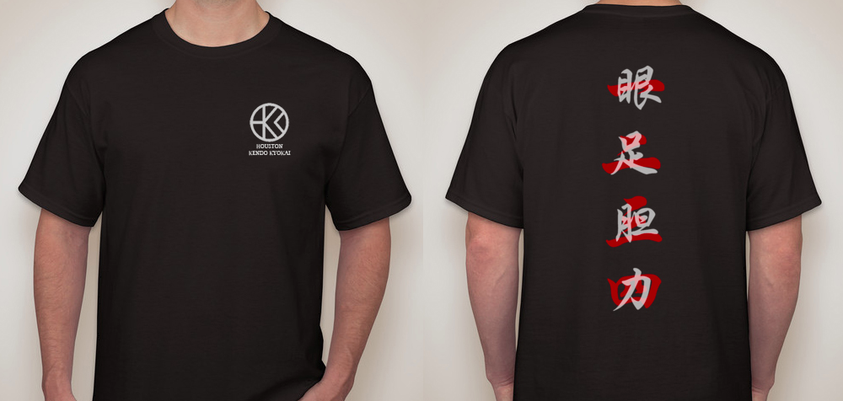

You can look cool while supporting Houston Kendo Kyokai. This limited edition single run T-shirts are $25 and they are made with premium athletic material. Please indicate the size on your registration form so we can have them ready for you at the seminar.

Back of the shirt kanji meaning.

1. 一眼 - Gan (eyes)
2. 二足 - Soku (legs)
3. 三胆 - Tan (lower abdomen or sei-ka-tan-den, also sometimes interpreted as courage or "guts")
4. 四力 - Riki (Strength)

Thank you,
HKK

WAIVER OF LIABILITY
FOR PARTICIPATION OF EVENTS IN THE October 28 - 29, 2017

I, the below signed Participant, intending to be legally bound, do hereby, for myself, my heirs, assigns, executors and administrators, waive, release, and forever discharge any claims for damages, illness, injuries and/or death which may hereafter accrue to me against the All United States Kendo Federation, Houston Kendo Kyokai, the Southwest Kendo & Iaido Federation, Gilruth Fitness Center, The Chinese Community Center, NASA, 888 Chinese Restaurant , The City of Houston, The City of Seabrook and their members, employees, instructors, agents, invited sensei’s and participants in the October 2017 Kendo event at Gilruth Fitness Center for any and all damages which may be sustained or suffered by me in connection with, in association with, travel to or from or participation in the Kendo Event. I further agree to indemnify and hold harmless the All United States Kendo Federation, Houston Kendo Kyokai, the Southwest Kendo & Iaido Federation, Gilruth Fitness Center, The Chinese Community Center, NASA, 888 Chinese Restaurant , The City of Houston, The City of Seabrook and their members, employees, instructors, agents, invited Sensei and Participants in the October 28 - 29, 2017 Kendo event for any claims I may have outlined herein.

Participant: (Print and Sign)

_______________________________________________________ Date: ________________

*Parent or Legal Guardian: (Print and Sign)

_______________________________________________________ Date: ________________

*(Note: Parent or Legal Guardian must sign is the Participant is under the age of eighteen years old)

